Key Points - Cactus | Images
Using Hotkeys  - G - Grab  - R - Rotate  - S - Scale | 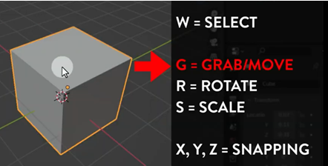
Lazy Viewport  - File is already downloaded above  - Select Edit - Preferences - Add-ons - Install  - Select lazyviewport.py from the folder and click install Add-On.  - Enable Lazy Viewport  Practice using the hotkeys to duplicate blocks and then G, R and S | 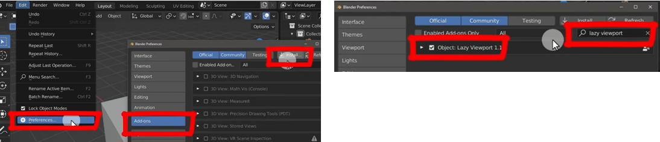
Edit Mode  - Tab switches between edit and object mode  - You can only edit one object at a time  - You will have different tools and menus in edit mode  Practice moving vertices, edges and faces | 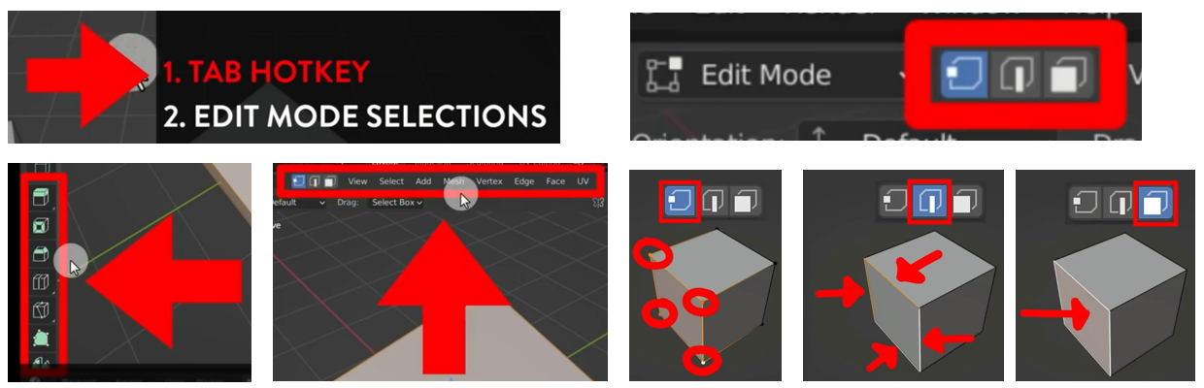
Extrude  - Tab Select the mesh and switch to Edit Mode  - Choose Face select [3] in Select Mode  - Choose Extrude [E] and then drag out the face you want to extrude  - Practice doing this several times so you are comfortable extruding different faces | 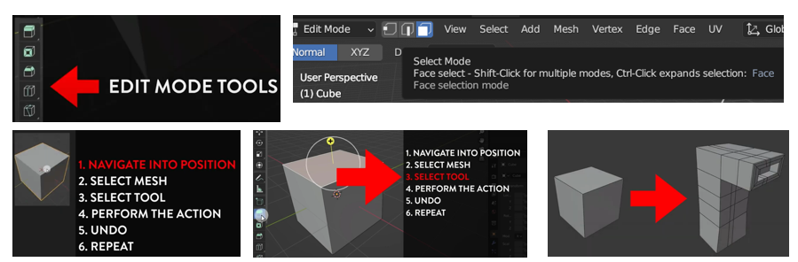
Inset  - Reduces the size of face  Merge  - Select two vertices using Shift  - Press M then At Center  Loop Cut  - Ctrl + R or select the loop cut tool  - Move to the centre of a section you want to cut into two | 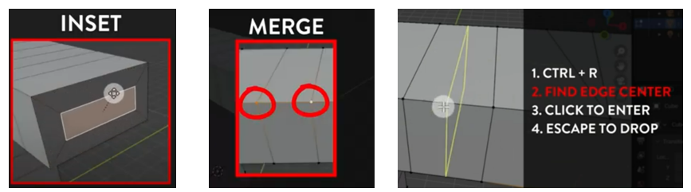
Cactus body  - Use the skills you have learnt in the previous videos to extrude, inset and loop cut a body of a cactus. | 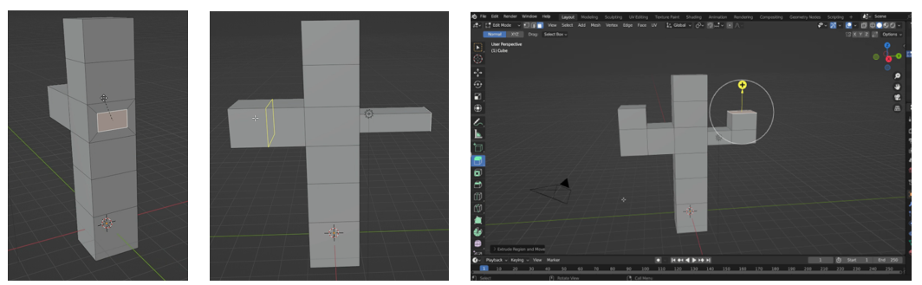
Face movement  - Remember we are using destructive techniques so you can't just hit undo if you go too far  - Repeat the previous process but move one of the faces before extruding the arm on one side | 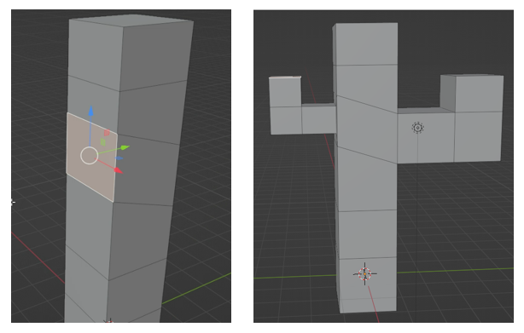
Smooth  - To smooth the edges use a modifier  - From the modifier menu (blue spanner) Select Add Modifier - Subdivision Surface  - Adjust the tops of the cactus by selecting the top face of each and using the scale (S) tool  - Add loop cuts to the arms and base to look more realistic | 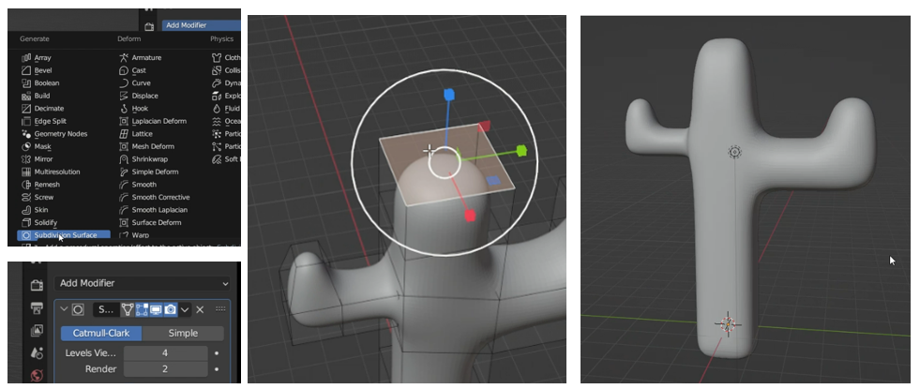
UV Wrapping Textures  - Select the Shading tab  - At the bottom adjust the base colour for simple colour  - Drag a cactus texture to the bottom and then link the Colour to Base Colour  - Switch to the UV Editing tab. Press A to select all faces on the right, then select UV - Smart UV Project and click OK. This will wrap the object correctly.  - To scale the texture on the left hand side Press A to select all then scale up to increase the times the texture repeats  - Try several of the textures to determine which one you prefer | 

